PR for MID DEVON WALKING FEST
11/07/24
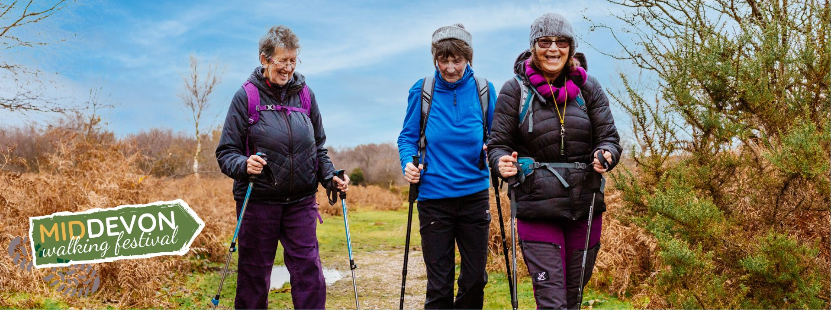
Mid Devon Walking Festival 2024 Debuting Soon
Taking place from 14 – 29 September 2024, the Mid Devon Walking Festival will showcase the stunning natural beauty and cultural heritage of the region like never before. Participants will have the opportunity to choose from an enticing selection of guided walks, each offering a unique perspective on the area's landscapes and history.
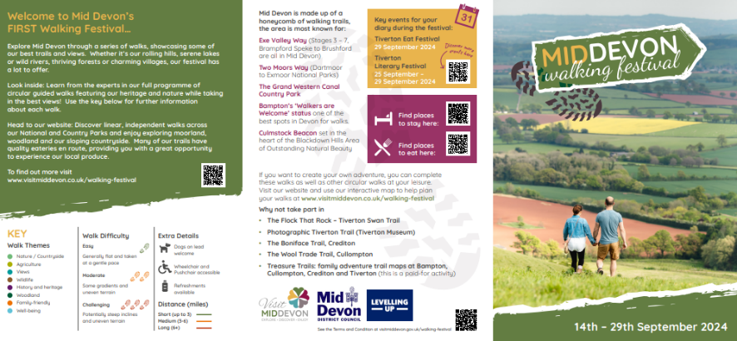
Residents and visitors can download the guided walk programme from the Visit Mid Devon website today or pick up a guide from the Tourist Information Centre and other tourism display stands when passing. The guide breaks down each walk by theme, difficulty rating, dog friendly, refreshments and accessibility, making it easy to spot the walk for you. The website also hosts a number of useful walking related blogs and event information during the festival.
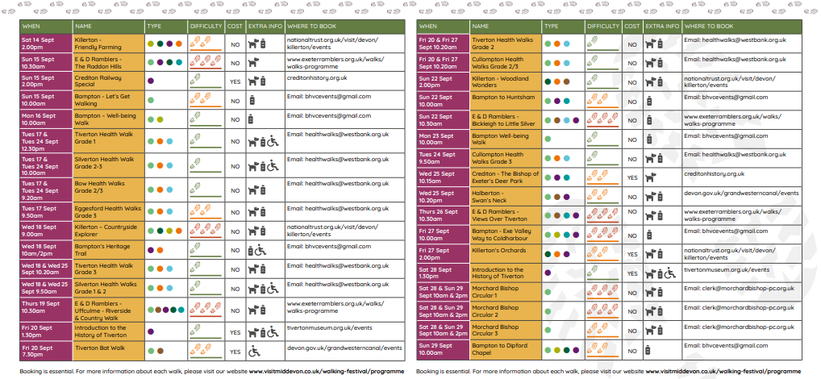
Cllr Keable for Planning and Economy states "We are thrilled to introduce the very first Mid Walking Festival and invite outdoor enthusiasts of all ages to join us for a celebration of our region's natural beauty and cultural heritage. Whether you're a seasoned hiker or just looking to connect with nature, there's something for everyone at every level of ability at this exciting event."
In addition to guided walks, the festival will feature a range of activities and attractions including live music and local artisan markets. Anyone wanting to discover our honeycomb of walking routes solo, can find handy instructions to navigate our interactive walking map to plan your route.
Organisations involved in delivering Mid Devon’s first walking festival include; Exeter Ramblers Association, Killerton – National Trust, Crediton Museum and History Society, Bampton Heritage Centre, Westbank, The Grand Western Canal & Country park, Tiverton Museum and Morchard Bishop Parish Council.
For more information about each walk and to reserve your spot, visit https://www.visitmiddevon.co.uk/walking-festival/ or follow us @visitmiddevon for the latest updates and announcements. This festival has been funded by the Shared Prosperity Fund.
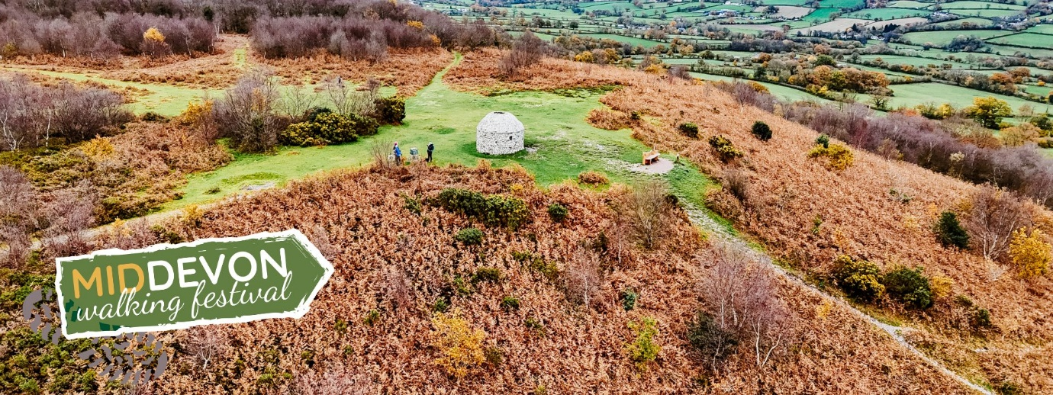
END
Contact for more information
Amy Dugard – adugard@middevon.gov.uk

